MODEL BUILDING

MULTIPLE MODEL ALGORITHM:-

CLASSIFICATION:-

The importance of environmental contributions and the reversibility of some thyroid diseases were recognized ([21](javascript:;)). In the 1990s the importance of the transient and bipolar clinical evolution of several thyroid diseases was stressed, and the need to update the nomenclature of thyroid diseases was acknowledged ([22](javascript:;)). Some recent books on internal medicine have begun to report some of the newly identified thyroid diseases as special topics, taking into account molecular mechanisms of thyroid diseases and the evolution of autoimmune thyroid diseases

| **Condition** | **TSH Level** | **Thyroid Hormones** | **Comments** |
| --- | --- | --- | --- |
| Overt hyperthyroidism | <0.1 mIU/L or undetectable | Elevated T4 or T3 |  |
|  | | | |
| Overt hypothyroidism | >4.5 mIU/L | Low T4 |  |
|  | | | |
| Subclinical hyperthyroidism | <0.1 mIU/L | Normal T4 and T3 | Clearly low serum TSH |
| 0.1 to 0.4 mIU/L | Normal T4 and T3 | Low but detectable |
|  | | | |
| Subclinical hypothyroidism | 4.5 to 10 mIU/L | Normal T4 | Mildly elevated TSH |
| ≥10 mIU/L | Normal T4 | Markedly elevated TSH |

Source: Jameson 2008,[19](https://www.ncbi.nlm.nih.gov/books/NBK285870/table/ch1.t1/) Surks 2004[8](https://www.ncbi.nlm.nih.gov/books/NBK285870/table/ch1.t1/)

PREDICTION:-

A novel machine learning-based thyroid disease prediction approach is proposed that focus on the multi-class problem. Contrary to previous studies that focus on the binary or three-class problem, this study considers a five-class disease prediction problem.

Four feature engineering approaches are investigated in this study to analyze their efficacy for the problem at hand. It includes forward feature selection (FFS), backward feature elimination (BFE), bidirectional feature elimination (BiDFE), and machine learning-based feature selection using an extra tree classifier.

For experiments, five machine learning models are selected based on their reported performance for disease prediction, including random forest (RF), logistic regression, support vector machine (SVM), AdaBoost (ADA), and Gradient boosting machine (GBM). Moreover, three deep learning models are adopted as well, which include convolutional neural network, long short-term memory (LSTM) network, and CNN-LSTM. Performance is evaluated in terms of confusion matrix, 10-fold cross-validation, and standard deviation, in addition to accuracy, precision, recall, and F1 score.

Several thyroid disease detection and classification approaches have been presented in the literature. For example, Garcia et al. [[9](https://www.ncbi.nlm.nih.gov/pmc/articles/PMC9405591/#B9-cancers-14-03914)] predicted the high probable molecules initiating the thyroid hormone homeostasis using machine learning algorithms RF, LR, GBM, SVM, and deep neural networks (DNN). The early prediction of the molecules is helpful for further testing in the first stages of thyroid disease. The molecular events were obtained from ToxCast datasets for running the experiments. The article reported that Thyroid Peroxidase (TPO) and Thyroid Hormone receptor (TR) achieved the best predictive performance with an F1 score of 0.83 and 0.81, respectively. The authors in [[10](https://www.ncbi.nlm.nih.gov/pmc/articles/PMC9405591/#B10-cancers-14-03914)] utilized the image processing techniques and feature selection methods to pick the important features from the dataset and achieve the best performance for thyroid disease prediction.

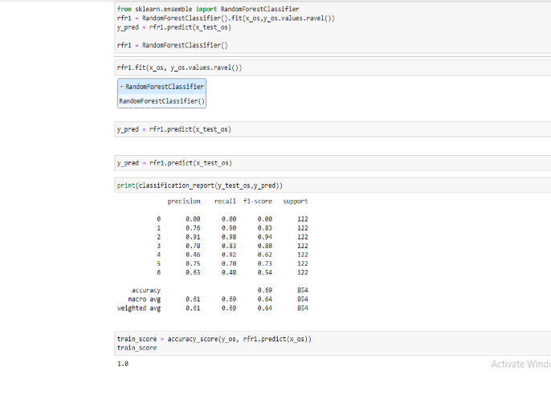

**APPROXIMATION:-**

**Objective:**Cricothyroid approximation is performed in male-to-female transsexuals to raise the pitch of the voice often accompanied by a thyroid chondroplasty, an aesthetic reduction of the thyroid cartilage. The survey was conducted to ascertain patient satisfaction with the procedures.

**Study design and setting:**Fifty-four patients had the procedures performed in our department over an 8-year period; 45 patients were sent postal questionnaires to evaluate patient satisfaction with the appearance of the laryngeal prominence, pitch of the voice, and which they found more beneficial, the surgery or speech therapy.

**Results:**A response rate of 93% was obtained; 86% of patients thought their laryngeal profile had improved, 79% thought their voice had improved, and 55% thought that surgery and 21% thought that speech therapy had helped more in improving the voice. Overall, 79% were satisfied with the results of the surgery.

**Conclusions:**Cricothyroid approximation and thyroid chondroplasty have a high patient satisfaction rate.